Marmara Üniversitesi Mühendislik Fakültesi
Elektrik-Elektronik Mühendisliği

Laboratory Manual

EE 3011

Electronics I

Experiment (4) Diode Characteristics

Ebubekir Mutugan
150720002

Spring 2024

Objectives

Experiment (4) Diode Characteristics

- To experimentally determine the IV characteristics of a general purpose diode.
- To analyze a simple diode circuit using graphical methods.
- To study the application of diodes in logic gate design.

Pre-lab Work
Analyze the two circuits using the constant voltage diode model (𝑉_{𝐷0}=0.7 V).

Solution
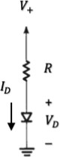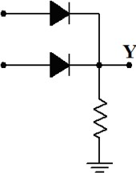
𝑅
+
𝑽_{𝑹}
_
𝑉_{𝐴}
𝑉_{𝐵}
Inputs
𝑉_{F}
Output
𝑅

Figure 1: Diode IV curve. Figure 2: A diode logic gate circuit.

Equipment

Table 1. Equipment for experiment 4.

Page2
 | Equipment | Model | Serial No. | Stock No.
1 | BreadBoard Station
2 | 1 kΩ Resistor (2W, 5%)
3 | Silicon Diodes (2) | 1N4001 | https://www.onsemi.com/pub/Collateral/1N4001-D.PDF
4 | Multi-meter (1)
5 | Probes and cables

Experimental Procedure
Part (1): Diode Forward IV Characteristics.
- Start first by checking if the diode is not damaged. Set the multimeter on resistance measurement. Touch the black lead (negative) of the multimeter to the cathode of the diode (refer to figure 3) and the red lead (positive) to the anode. In this configuration, the diode is forward-biased, and you should get a resistance reading between 1 kΩ and 10 MΩ. Next, switch the leads to the opposite terminals. The diode is now reverse-biased, and the reading should be infinity. If the readings are the same in both directions, the diode is damaged.

Page3
- Connect the circuit in figure 1, with 𝑅=1 kΩ. Pay a special attention to how you connect the two terminals of the diode by referring to figure 3.
- Starting with 0 volts, increase the DC voltage source 𝑉" up to 2 volts in the steps given in table 2. In each setting, measure the voltage across the diode and across the resistor using the multi-meter. Enter your measurements in table 2.

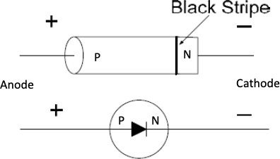
Figure 3: Diode marking.

Part (2): Graphical Analysis of Diode Circuits.
- Consider again the circuit in figure 1, with a 𝑅=1 kΩ. and 𝑉"=2 V.
- Measure the voltages 𝑉_{𝐷} and 𝑉_{𝑅} using the multi-meter. Enter your measurements in table 3.
- With the diode removed from the circuit (open-circuit), measure the voltages 𝑉_{𝐷} and 𝑉_{𝑅}. Enter your measurements in table 3.
- With the diode shorted (a wire is placed instead), measure the voltages 𝑉_{𝐷} and 𝑉_{𝑅} using the multi-meter. Enter measurements in table 3.
Part (3): Diode Application as a Logical Gate.
- Connect the circuit shown in figure 2.
- Connect the inputs 𝑉_{𝐴} and 𝑉_{𝐵} to 0 volts or +5V (for a total of four combinations), as shown in table 5. In each combination, record the value of the output voltage 𝑉_{F} in table 5.

Results and Analysis

Part (1): Diode Forward IV Characteristics.
- Calculate the diode current (𝐼_{𝐷}) in table 2.
- Now, use the graphing space below to plot the diode characteristics 𝐼_{𝐷} (vertical axis) versus
𝑉_{𝐷} (horizontal axis). Appropriately label your plot.
- Does the curve resemble the usual diode IV curve? Explain any discrepancies. Answer:
Yes, in this graph, just like in the diode graphs, after not passing current up to a certain voltage value, it starts to pass current through the diode when it exceeds 0.7 volts.

Page4

Table 2. Measurements for Part (1).

DC Input 𝑉& (V) | 𝑉_{𝐷} (V) | 𝑉_{𝑅} (V) | 𝐼_{𝐷}= 𝑉_{𝑅}/𝑅 (mA)
0.0 | 0.0 | 0.0 | 0.0
0.3 | 0.3 | 0 | 0
0.5 | 0.449 | 0.051 | 0
0.6 | 0.485 | 0.115 | 0.115
0.7 | 0.509 | 0.191 | 0.191
0.8 | 0.525 | 0.275 | 0.275
0.9 | 0.538 | 0.362 | 0.362
1.0 | 0.548 | 0.452 | 0.452
1.2 | 0.564 | 0.636 | 0.636
1.6 | 0.586 | 1.014 | 1.014
2.0 | 0.6 | 1.4 | 1.4

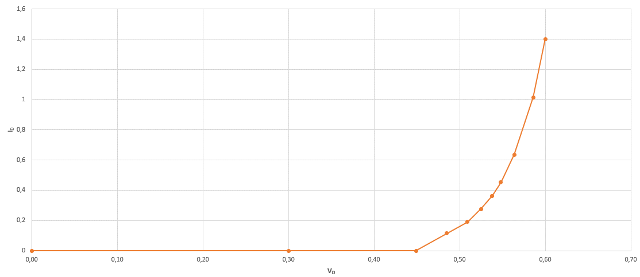

Graph 1: Diode IV characteristics.

Part (2): Graphical Analysis of Diode Circuits.

- Calculate the diode current (𝐼_{𝐷}) in table 3 for all three cases.
- Now, on the same graphing space above (graph 1), draw the “load line” of the circuit. Use the second and third entries in table 3.
- The intersection point between the load line and the diode characteristics curve is the “operating point” of the circuit. Find this point from the graph and record it in table 4.
- Also, record in table 4 the experimental current value (table 3, first entry) and the theoretical current value (from pre-lab calculations).
- Calculate the percent differences. Which value do you think is more accurate? Explain.
Page5

Table 3. Measurements for Part (2).

Diode | 𝑉_{𝐷} (V) | 𝑉_{𝑅} (V) | 𝐼_{𝐷}= 𝑉_{𝑅}/𝑅 (mA)
Included | 0.6 | 1.4 | 1.4
Removed | 0 | 2 | 0
Shorted | 2 | 2 | 2

Table 4. Calculations for Part (2).

𝐼_{𝐷} (mA) Experimental value | 𝐼_{𝐷} (mA) Graphical value | %  Difference | 𝐼_{𝐷} (mA) Theoretical value | %  Difference
1.3 | 1.4 | 7.15 | 1.4 | 7.15

Part (3): Diode Application as a Logical Gate.
- From the results in table 5, what logic function does the circuit perform?
- Diodes are not commonly used in the design of logic gate. Investigate and explain why not?

Answer:

They exhibit non-linear behavior and lack amplification capabilities. Logic gates require precise switching characteristics and amplification to ensure reliable operation, which diodes alone cannot provide. Instead, transistors, which offer both amplification and switching capabilities, are predominantly used in logic gate designs.

Table 5. Measurements for Part (3).

𝑉_{𝐴} (V) | 𝑉_{𝐵} (V) | 𝑉_{F} (V)
0 | 0 | 0
0 | 5 | 4.34
5 | 0 | 4.34
5 | 5 | 4.38

Page6

LTspice Simulations

Include with your report LTspice simulation results of all parts of this experiment.

Conclusions and Remarks

Write below all your conclusions/remarks on this experiment.

Part 1

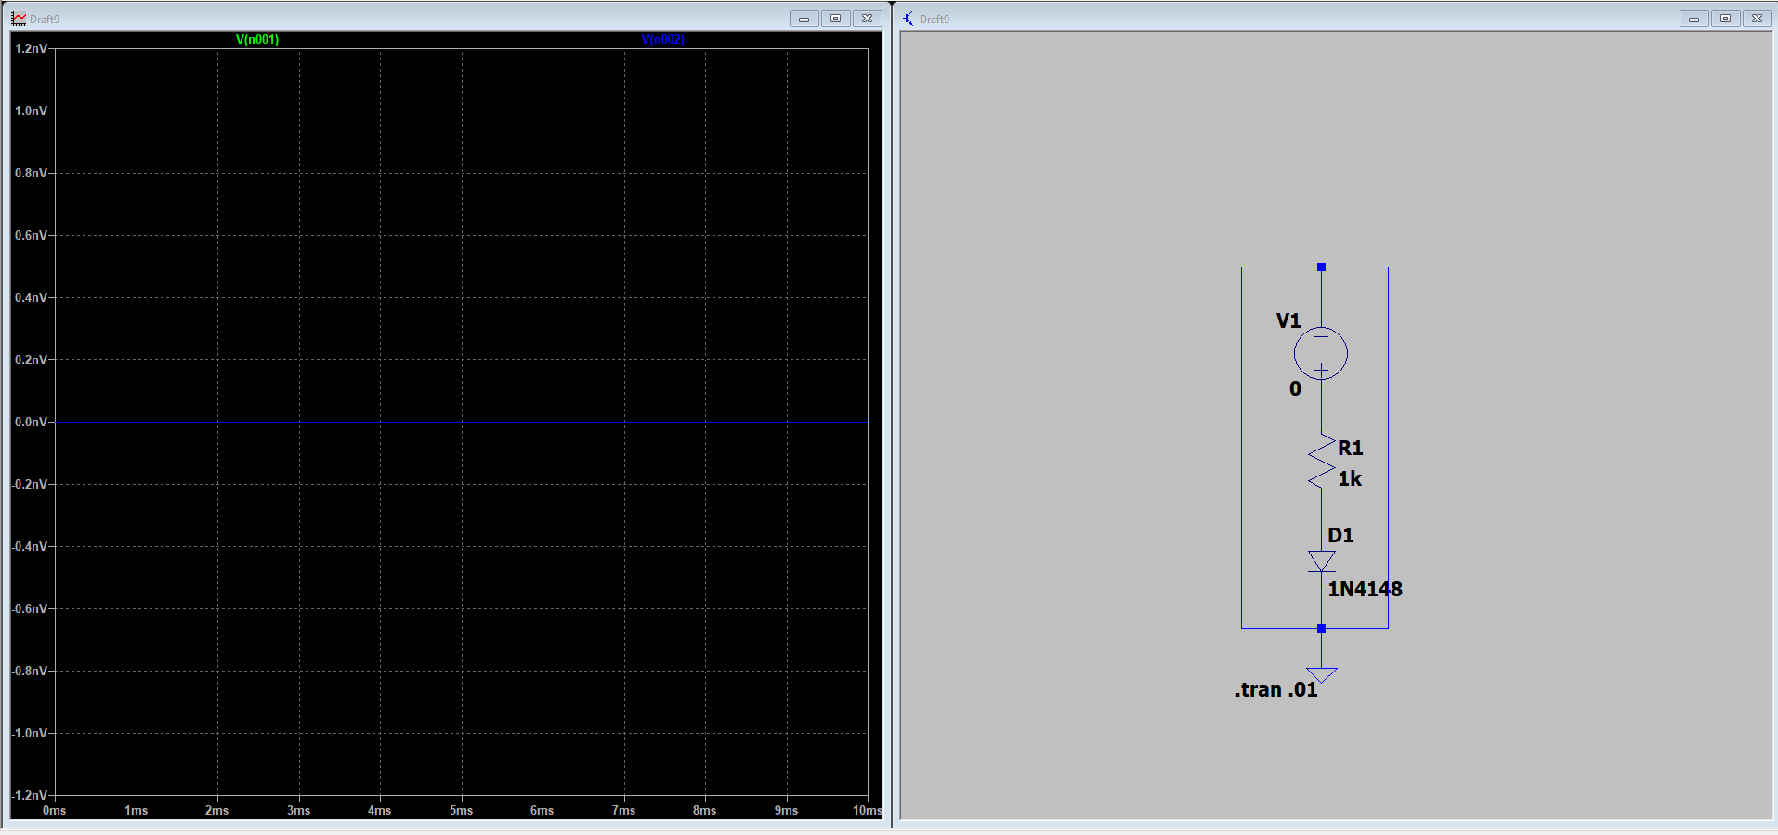

0V

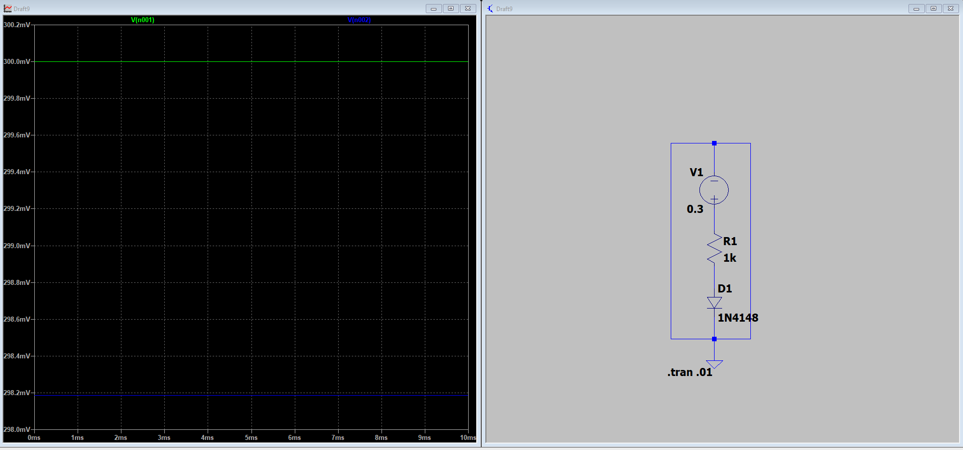

0.3V

Page7
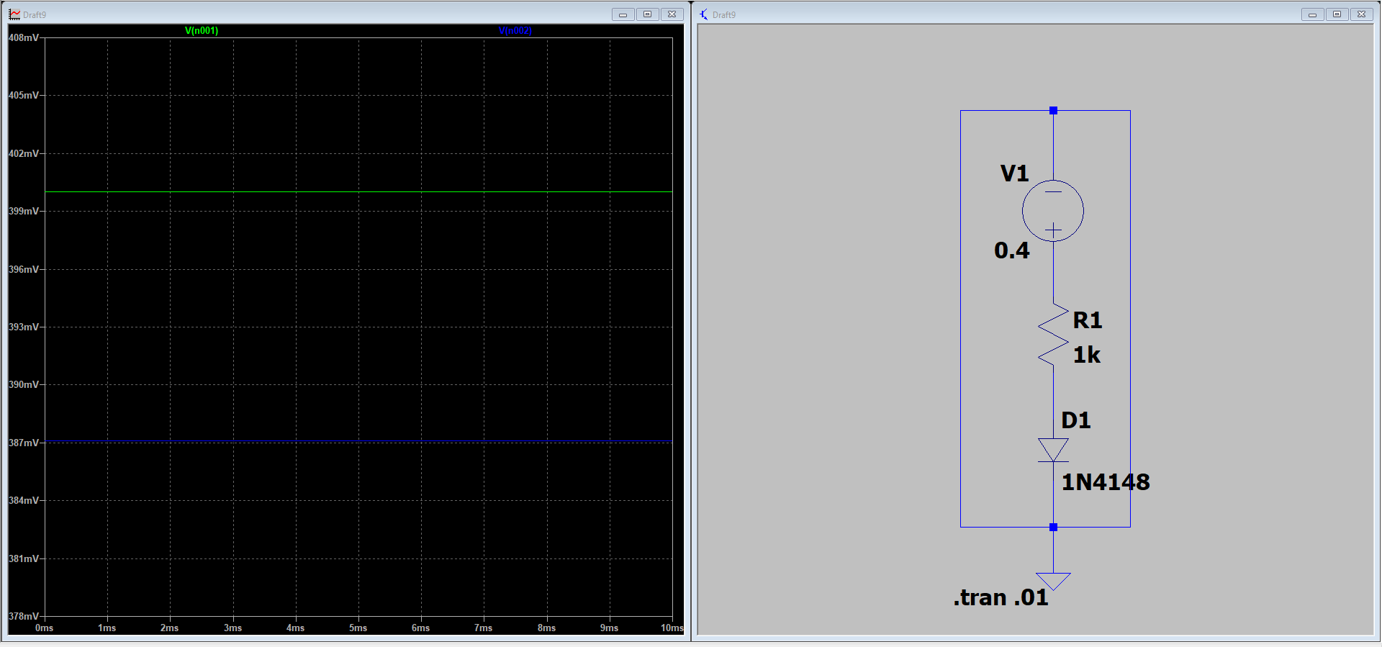

0.4 V
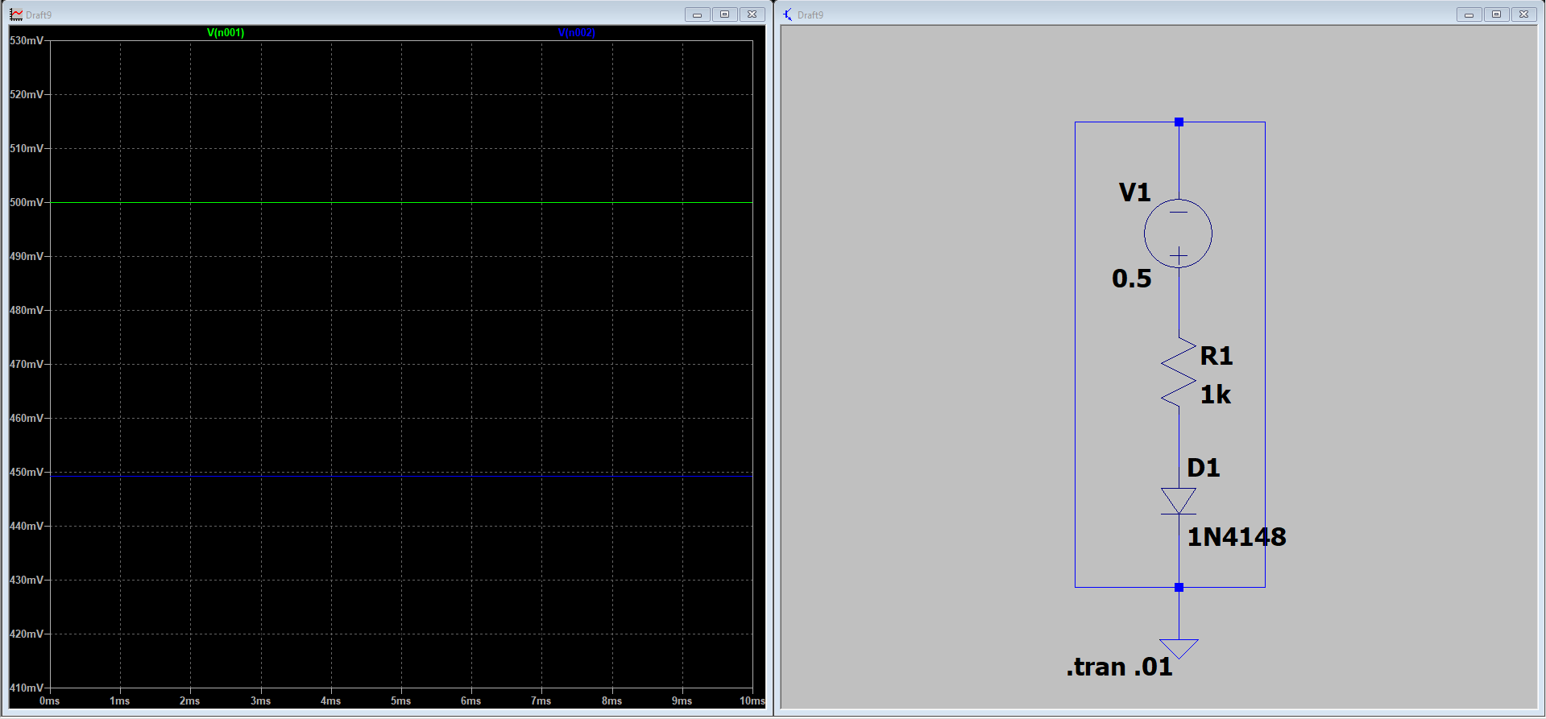

0.5V
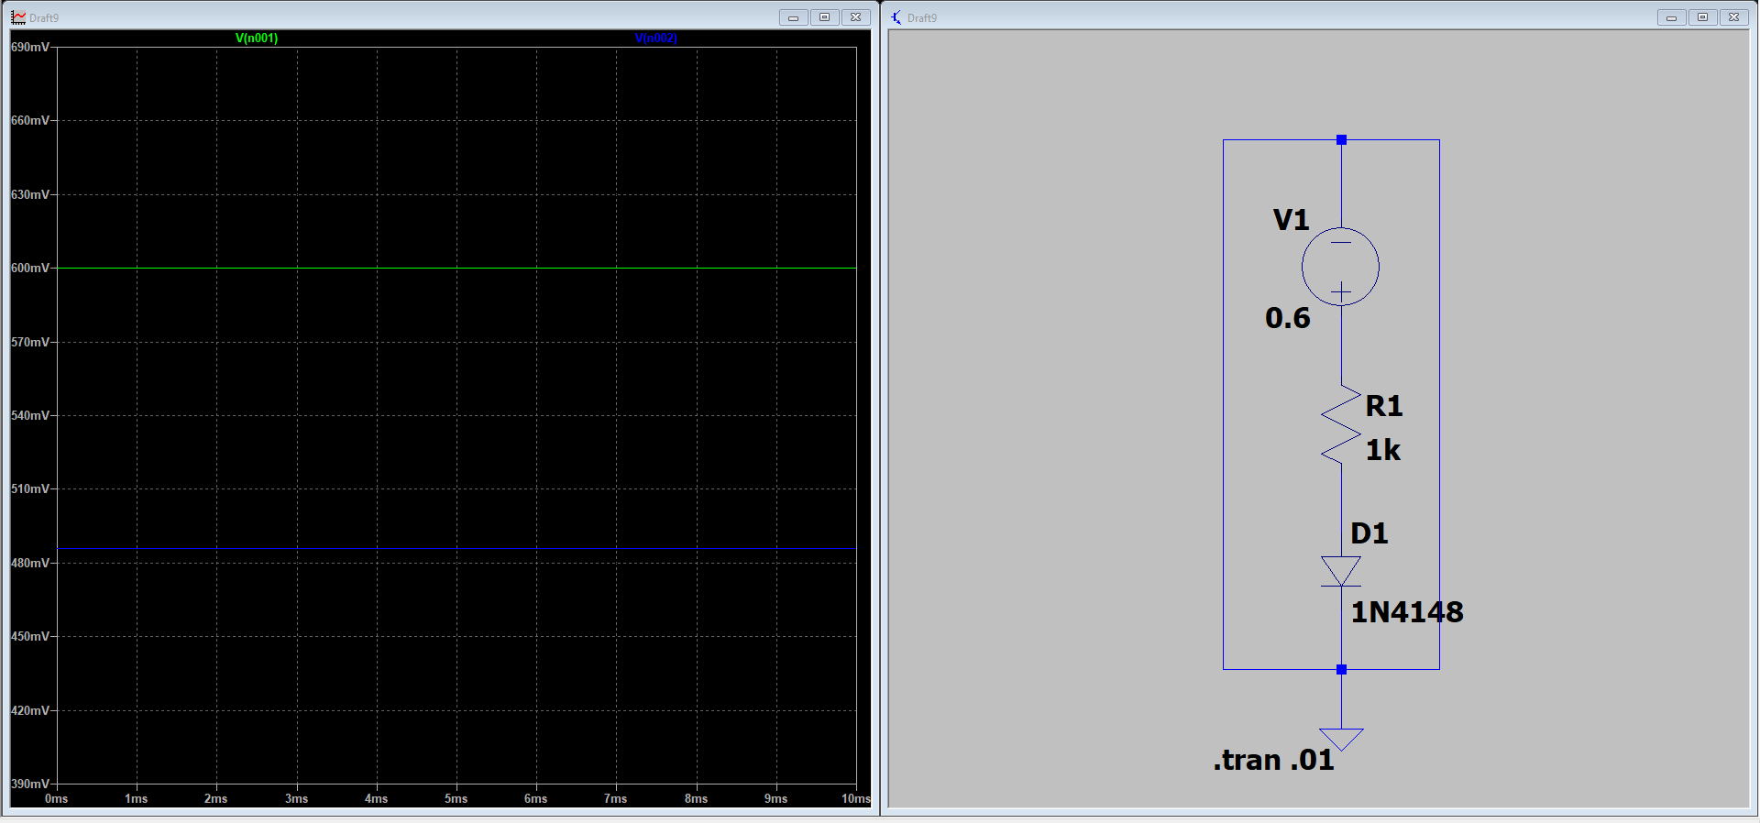

0.6 V

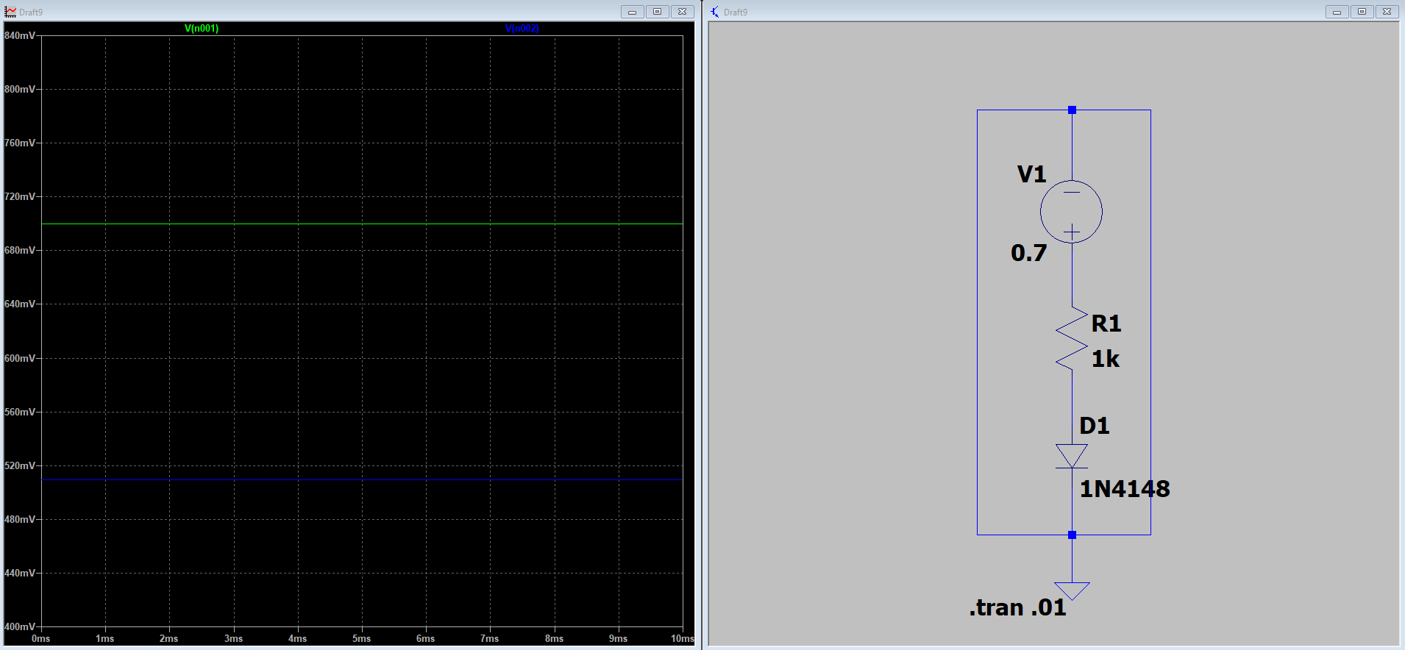

0.7V
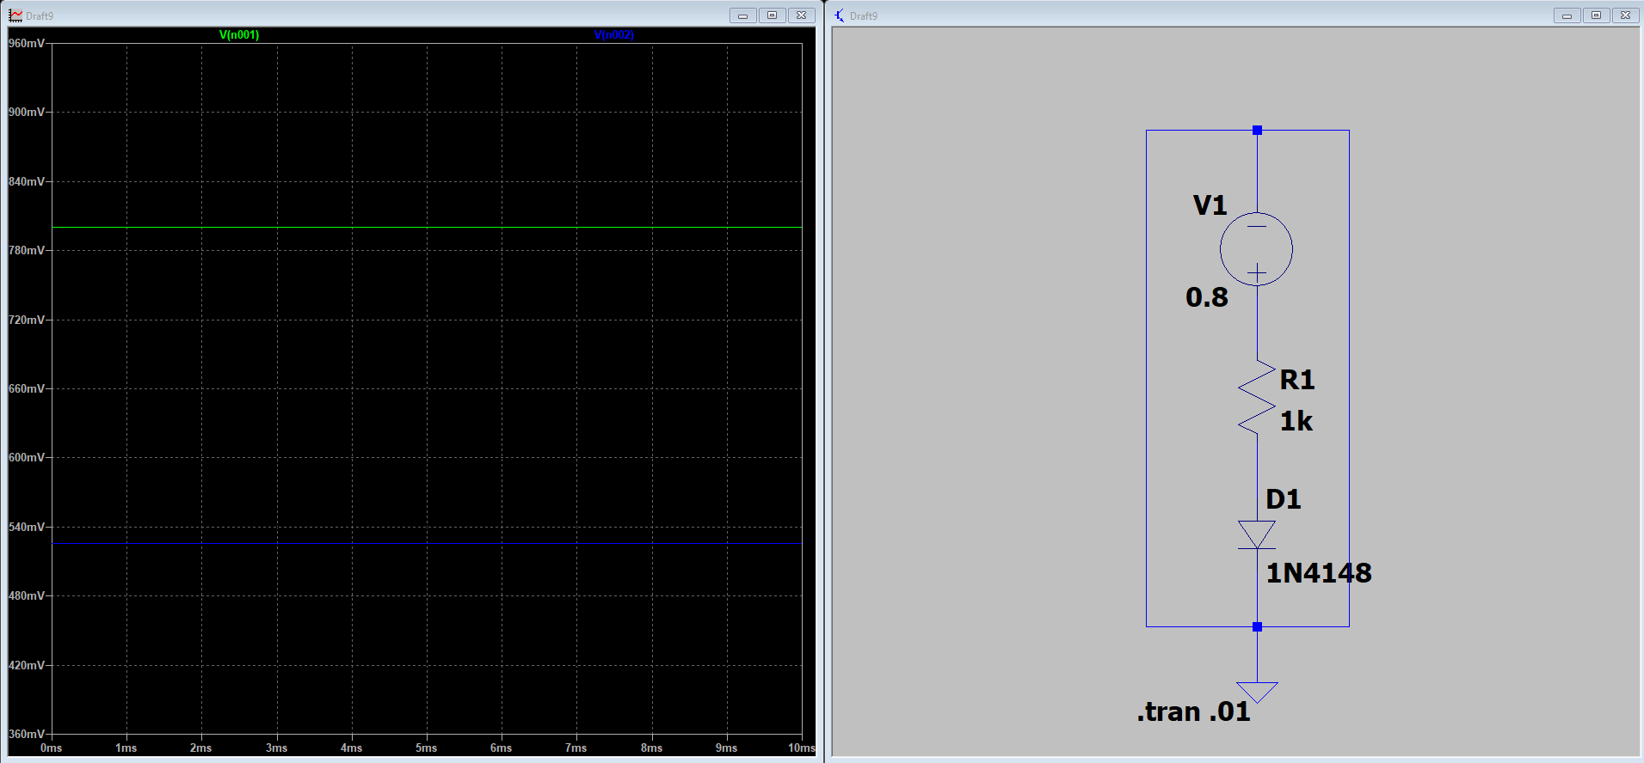

0.8V

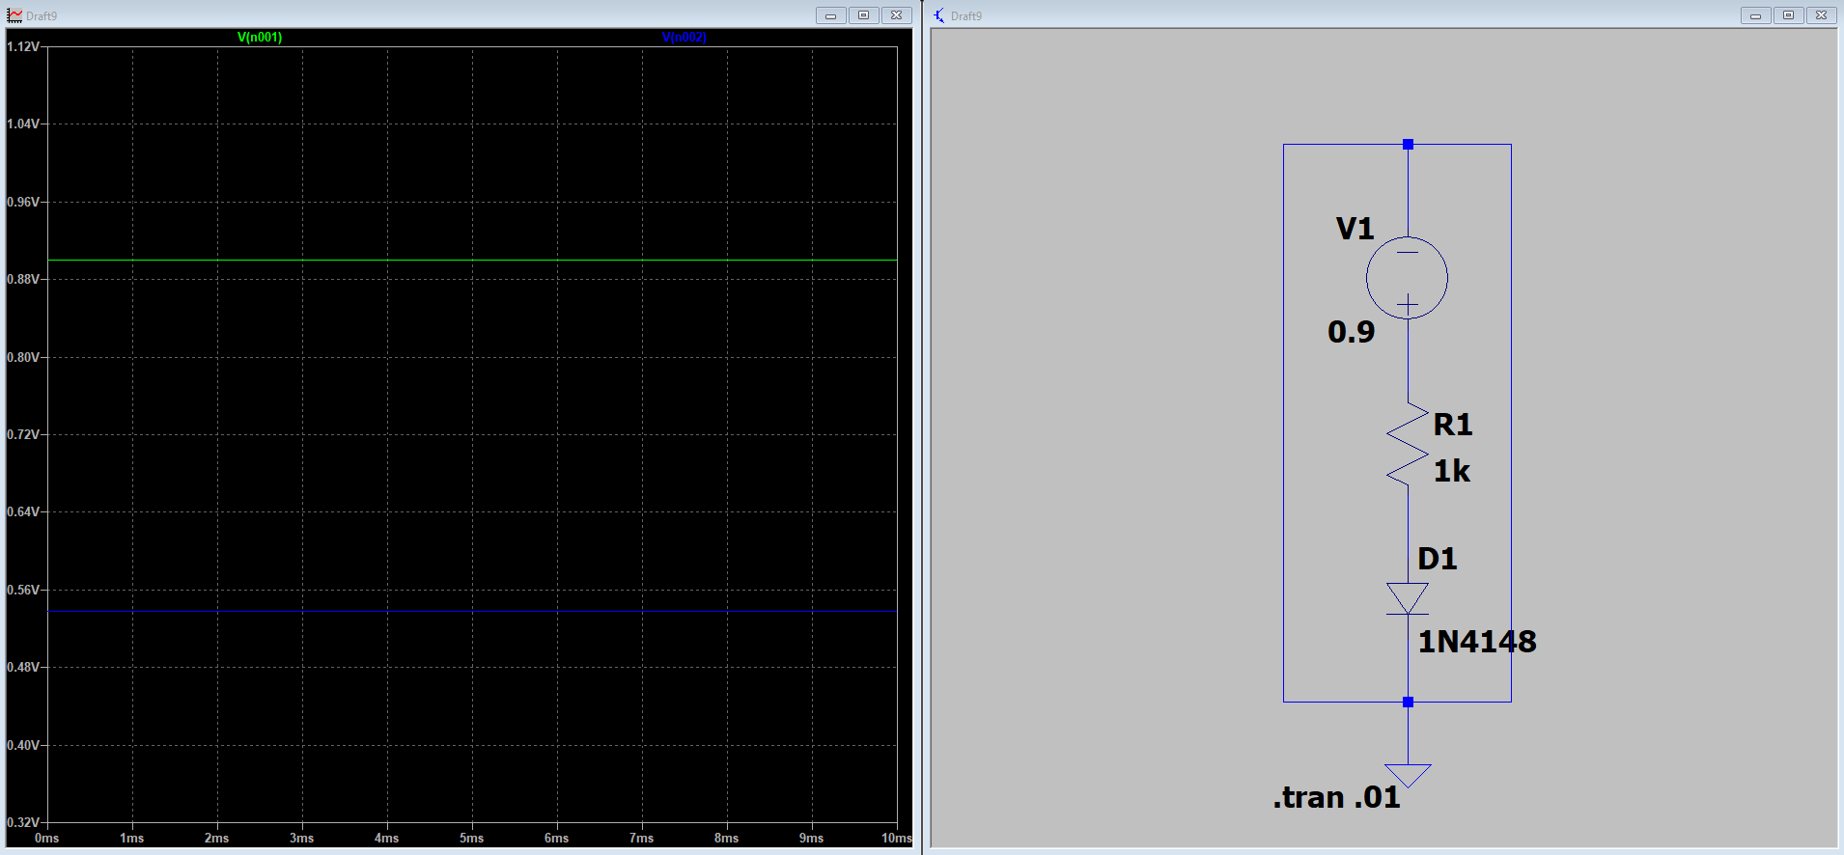

0.9V

Page8

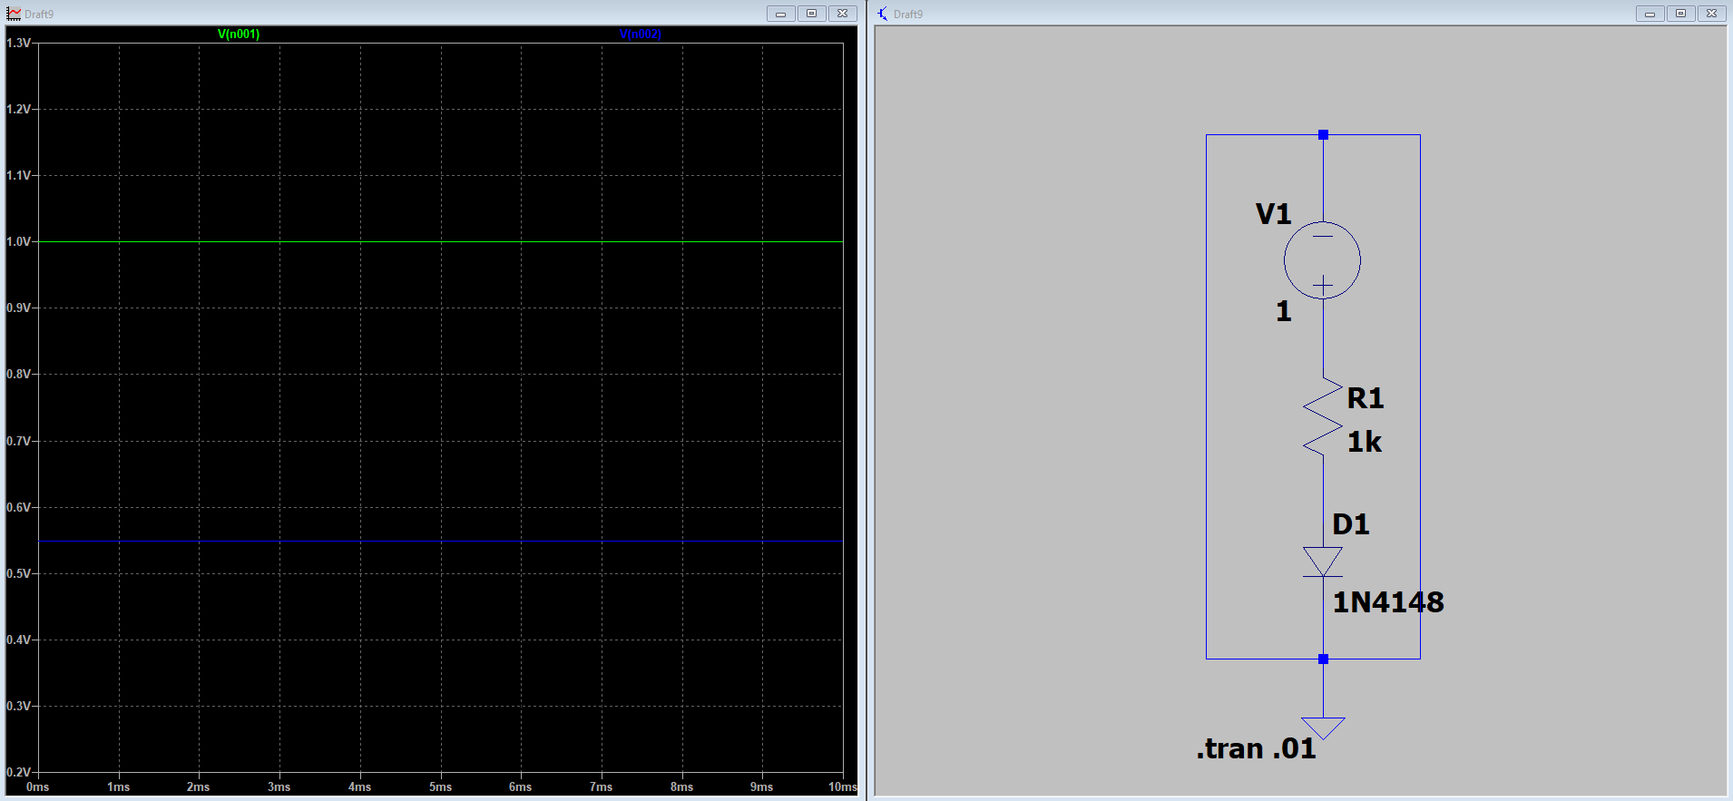
1V
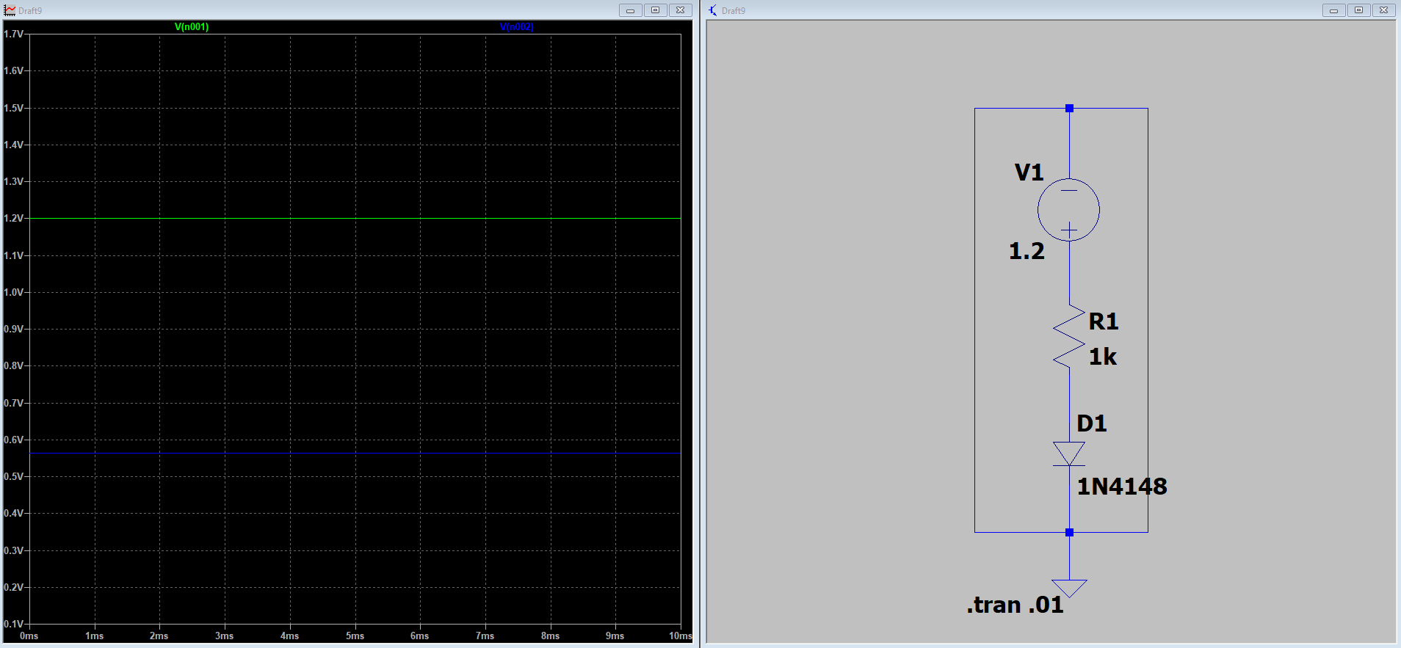

1.2V
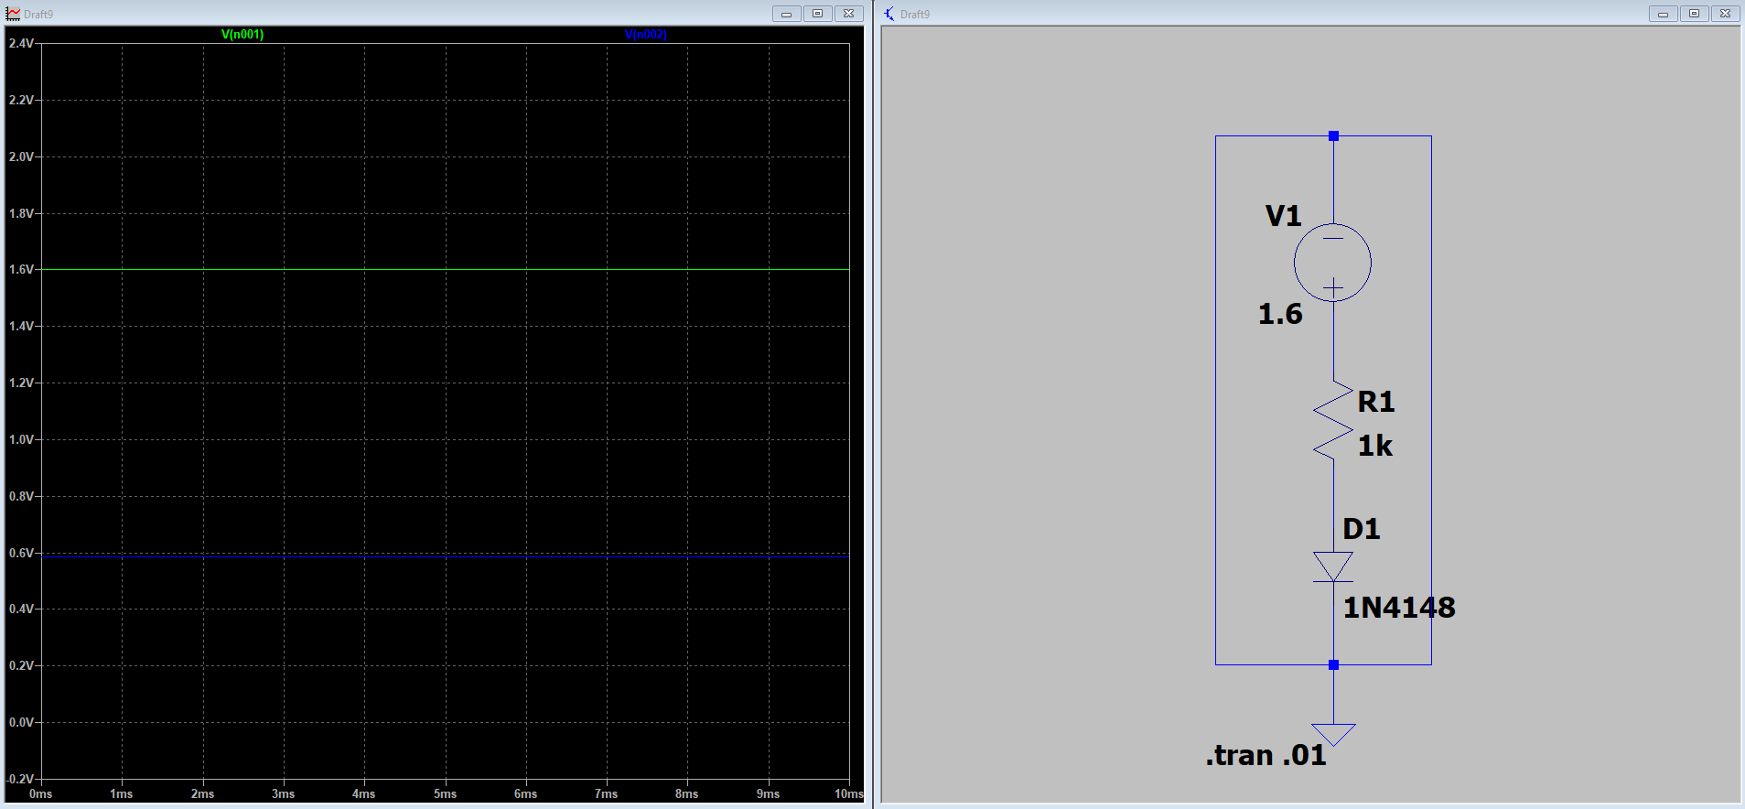
1.6V

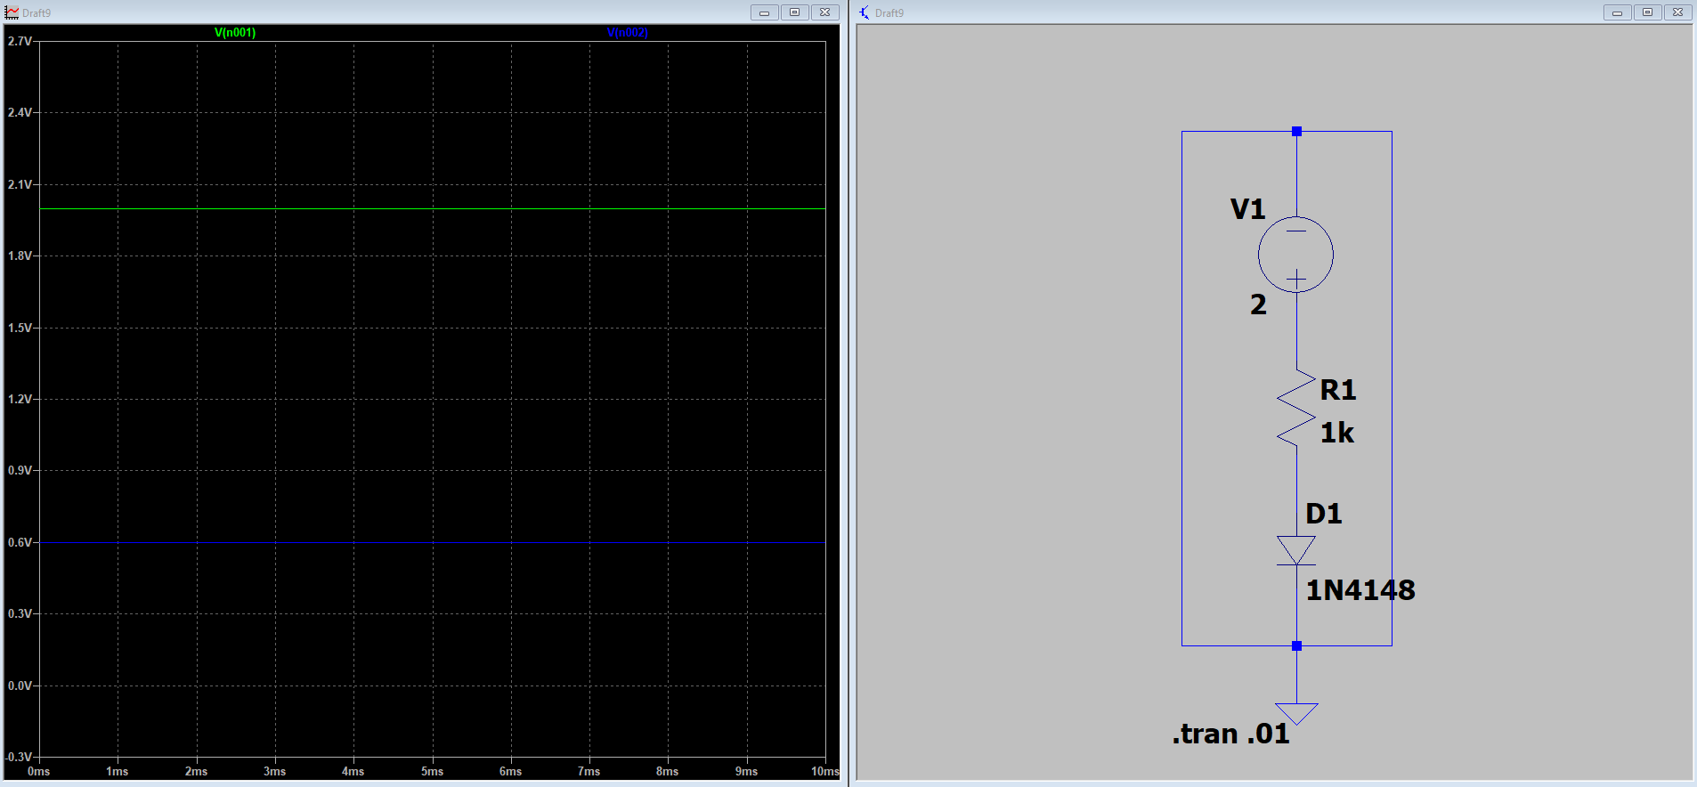
2V

Part 2

Normal Circuit

Page100

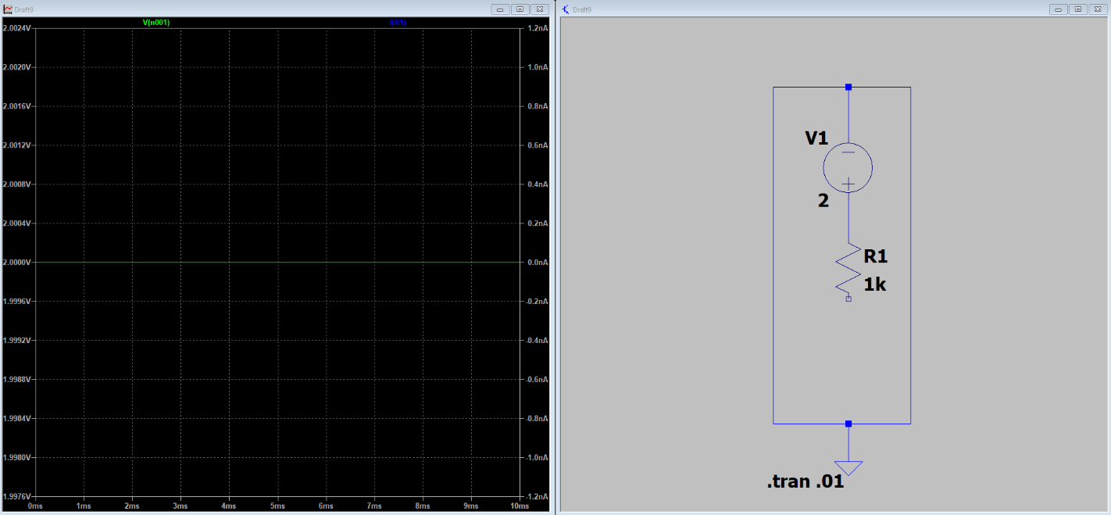
Open Circuit
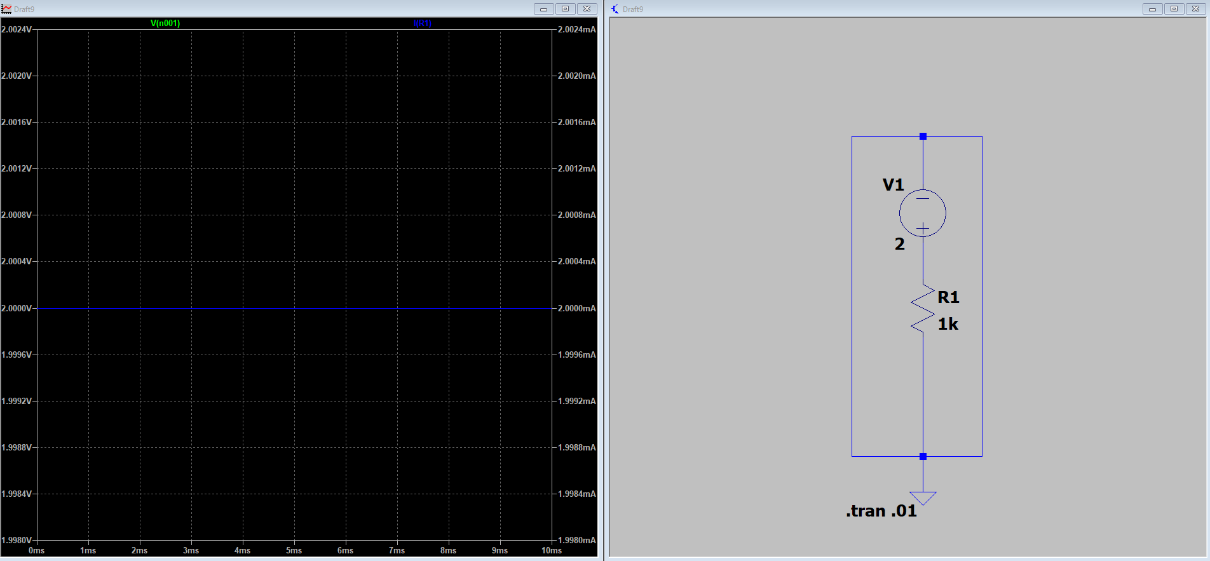

Short Circuit

Part 3
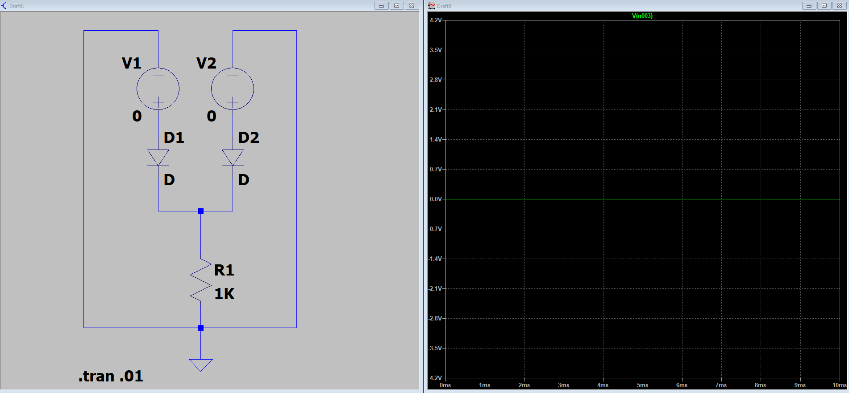

D₁ = 0V, D₂ = 0V

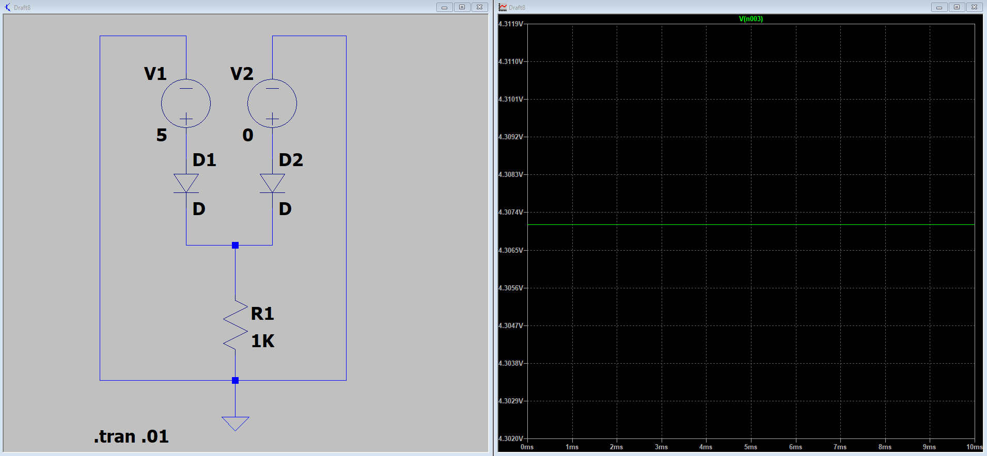

D₁ = 5V, D₂ = 0V

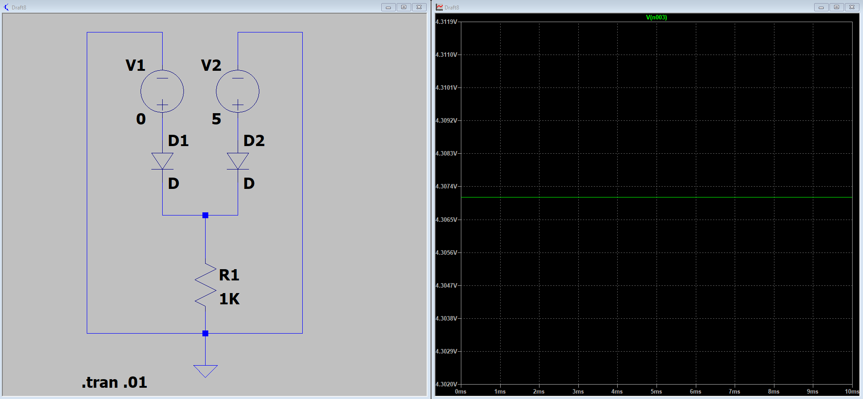

D₁ = 0V, D₂ = 5V
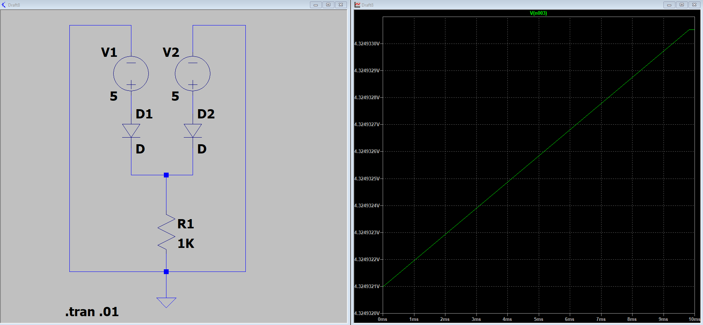

Page12

D₁ = 5V, D₂ = 5V

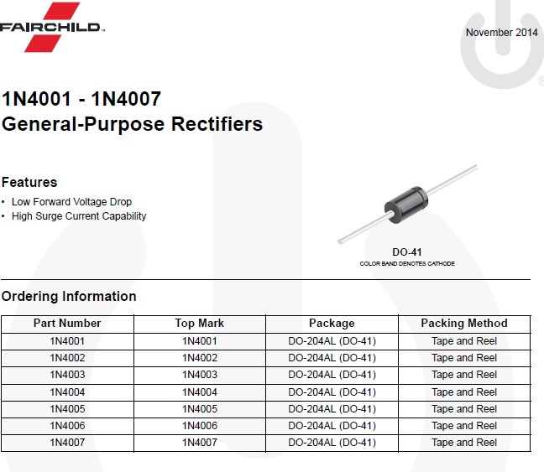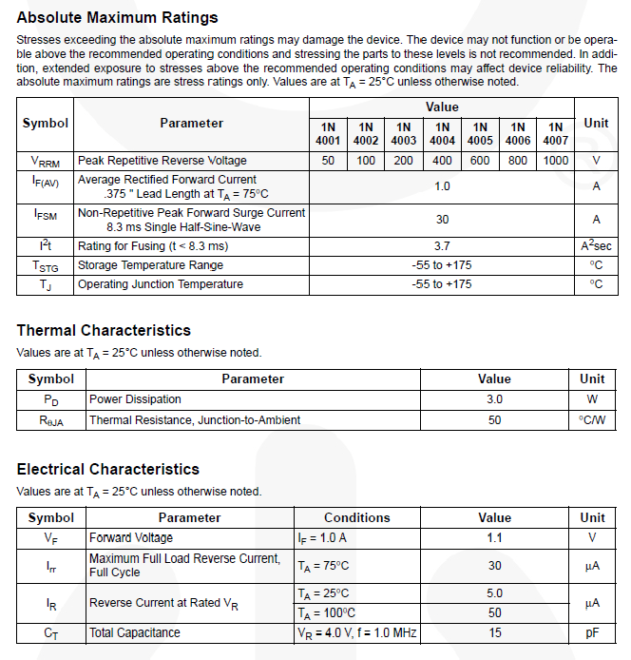
Page13

